Liver cells grown with new reprogramming method
By Bradley J. Fikes10 A.M.FEB. 23, 2014
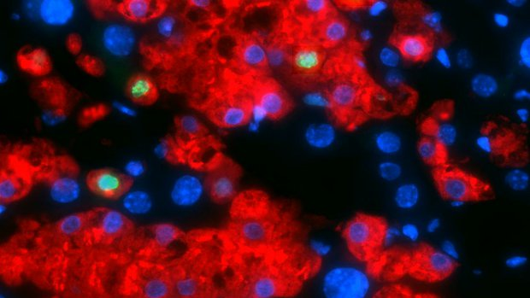Human albumin (red) and another human protein called Ki67 (green) shows that human fibroblast-derived hepatocytes replicate both function and proliferation of hepatocytes after transplantation into mouse livers. — Milad Rezvani

A new cellular reprogramming shortcut by scientists at the Gladstone Institutes and UC San Francisco has produced what appear to be functional human hepatocytes. Created from skin cells, the reprogrammed cells proliferated and demonstrated function when transplanted into mice with liver failure.
The method avoids problems in earlier attempts that used the induced pluripotent stem cell route to grow hepatocytes from fibroblasts. Instead of regressing the skin cells to the embryonic-like pluripotent stage, the scientists cut the process short at a stage mimicking endoderm cells. These cells are parents of both skin and liver cells.
The cells were changed by applying genes transferred through retroviruses, then culturing them with growth factors to walk them back to what they called an "induced multipotent progenitor cell (iMPC)" stage, then to the endoderm stage. The scientists then applied other growth factors that differentiated the cells into what apparently were hepatocytes.
To test whether these cells actually functioned as hepatocytes, researchers implanted them into mouse models of liver failure. The cells proliferated and displayed signs of hepatocyte function.
Study results were reported online Sunday in the journal Nature by scientists led by Sheng Ding of Gladstone and Holger Willenbring of UCSF. Ding joined Gladstone in 2011 after a distinguished career at The Scripps Research Institute.
One drawback of using pluripotent cells is they form tumors; so any cells grown from them must be carefully screened before transplantation. The new method appears to have solved this problem.
"Unfractionated iMPC-Heps did not form tumours, most probably because they never entered a pluripotent state," the study stated.
Moreover, induced pluripotent stem cells couldn't be reliably converted into liver cells, Ding said in a UCSF/Gladstone press release.
The ability of the new method to create cells that grow and function for months after transplantation "establishes them as promising candidates for in vivo modeling and autologous therapy of human liver diseases," the study stated.

